Daniel Fryer
Mod 2 assignment
8/22/2026

Web Site:
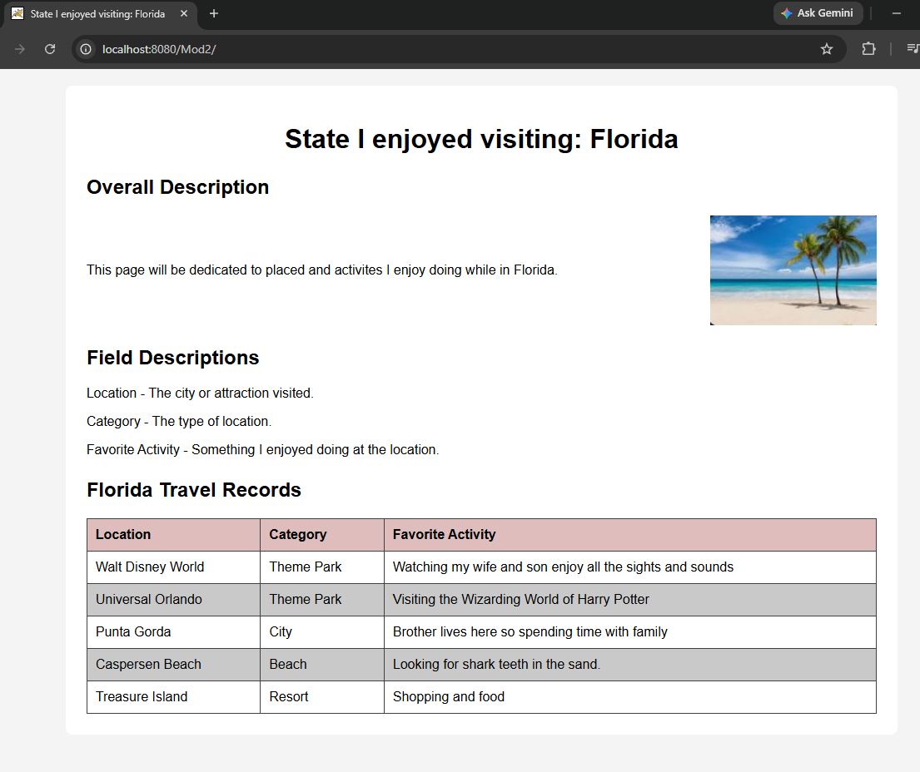

Tomcat:
